**CV SCREENING SYSTEM**

**USMAN INSTITUTE OF TECHNOLOGY**

**AL-RAHIM TEXTILE**

**INTRODUCTION TO SOFTWARE ENGINEERING**

**21 June 2019**

**Group Members**

**Areeba Kaleem 17B-015-SE 4th Semester -SE (A)**

**Nimra Mehboob 17B-045-SE 4th Semester -SE (A)**

**Aiman Ali 17B-004-SE 4th Semester -SE (A)**

**COURSE INSTRUCTOR**

**INSTRUCTOR NAME: USMAN WAHEED**

**CV SCREENING SYSTEM**

**Areeba Kaleem**

**Nimra Mehboob**

**Aiman Ali**

ABSTRACT / Executive Summary

Our application is based on the collection of CVs from various source points and choosing the CV according to the company’s requirements. Usually for this process to further carry on, useful time is wasted in finding whether the CV fits according to the requirements of the company a/c to work experience and education. In order to make work easier and manageable we have created this software. The work could have been carried out by using specific keywords or providing a template for the CV in order to make it easier for the software to work but that would have been a tiring work for the candidate to make another CV that fits our needs. Hence now our software works on finding specific words within the CVs that fit our requirement. In future we make this system more authentic and add new features according to the requirements of the company/market. And we can also willing to add a feature that the CV can download automatically according to their departments.

Table of Contents

**Title Page 1**

**Abstract / Executive Summary 2**

**List of Figures** **4**

**List of Tables** **5**

**Acknowledgments** **6**

**Introduction and Overview** **7**

**Background** **8**

**Aim and Statement of Problem** **9**

**Methods Assumptions and Procedures** **10**

**Available Relevant Solutions and Evaluation** **11**

**Analysis And Design** **12**

Business process workflow 12

Business document workflow 13

Context Diagram 13

Object Diagram 14

Actor Use case Diagram 14

Actor Use case narration18

Sequence Diagram 32

Input design prototype 33

Output design prototype 35

Database Diagram 37

**Implementation** **40**

Component Diagram 40

Deployment Diagram 41

**Support** **42**

**Conclusions and Suggestions for Future Work**…………………………………………………………… **43**

**References** **44**

**Appendices** **45**

**List of Symbols** **49**

**Glossary** **50**

**Index** **51**

LIST OF FIGURES

|  |  |  |
| --- | --- | --- |
| Figure No. | Description | Page No. |
| 1.1 | Business Process Workflow | 12 |
| 1.2 | Context Diagram | 13 |
| 1.3 | Object Diagram | 14 |
| 1.4 | Use Case Diagram | 14 |
| 1.5 | Use Case narration | 18 |
| 1.6 | Class Diagram | 28 |
| 1.7 | Sequence Diagram | 32 |
| 1.8 | Input Design Prototype | 33 |
| 1.9 | Output Design Prototype | 35 |
| 1.10 | Database Diagram | 37 |
| 1.11 | Component Diagram | 40 |
| 1.12 | Deployment Diagram | 41 |

LIST OF TABLES

|  |  |  |
| --- | --- | --- |
| Table No. | Description | Page No. |
| 2.1 | Use Case Table | 38 |
| 2.2 | Use Case Report | 38 |

Acknowledgments

First praise is to Allah, the Almighty, on whom ultimately we depend for sustenance and guidance. I would like to express my sincerest gratitude to my parents for their continuous support and effort, to my teacher ‘Usman Waheed’ for his invaluable guidance throughout the course, and his timely and efficient contribution which helped me shape this into its final form and I express my sincerest appreciation for his assistance in any way that I may have asked. I am also deeply indebted to my HOD ‘Prakash Lohana’ for his invaluable advice and supervision at the initial stages of this study. And to director of my institute ‘Dr. Zahir Ali Syed’ and of course to my prestigious institute ‘Usman Institute of Technology’ for providing us with the facilities and a platform towards the completion of our project. I also wish to thank my prestigious institute ‘Usman Institute of Technology’ for providing us with the facilities and a platform towards the completion of our project. I am particularly grateful to Zara Ali, the Executive HR manager and AL-RAHIM TEXTILE for giving us the opportunity to work on our project. I am also indebted to my colleagues at School of Computer Science particularly my group members. Special thanks, tribute and appreciation to all those their names do not appear here who have contributed to the successful completion of this project.

**CV SCREENING SYSTEM**

**Areeba Kaleem**

**Nimra Mehboob**

**Aiman Ali**

**Introduction and Overview**

Our project is about the compilation of CVs from various sources and selecting a CV that matches our requirements. It is able to search various key words from the given CVs and is able to go through the experience, education and technical knowledge of each individual CV. The organization ‘Al-Rahim Textile’ is a textile firm, who are hiring new recruits for various fields of work and we are incorporating our efforts by making them a software to select different CVs and find information in it as per needs and requirement. It is highly difficult for an individual to look into 200 or more CVs at a same time, it requires more time and money as the employee charges more money for his/her input. In regards to this, we are developing a program to view various CVs and choose the ones that fill the company’s requirements which is both requires minimal amount of time and is also cost effective.

**BACKGROUND**

Previously an employee had to open and read each CV and check the experience and education of each CV, it was both very costly and wasted a lot of useful amount of time.

Hence we introduced the searching CV option in our CV which works on finding specific keywords within the CV and showing the results to the HR or concerned manager. For example if a manager searches for the keyword experience then the word ‘experience’ would be highlighted throughout the CVs hence making it easier to go through the entire stacks of CV at a greater pace. Earlier after meeting each candidate remarks of each of them had to be added manually into an excel sheet, but through our software they are able to add and update the remarks of each candidate within the software which makes work easy and manageable. Only the candidates whose data, id and password are store into the software’s database are able to gain access. Our system is more efficient and reliable as compared to the earlier versions.

Aim and Statement of Problem

**AIMS**

The main purpose of this project is to make work easier for HR or the manager hiring the employee. Previously the HR manager used to check all the CV's one by one which was very time consuming. So we aim to develop software which make their work easier and saves their time by entering keywords in the system. Which will be tracked and highlighted by our system and they could easily find it, hence replacing the need to go through the whole CV. Secondly we aim to introduce a catalogue to our system which provides the Catalog and saves the employee details in data base. The HR manager can insert, update and delete data at a time.

**SUCCINCT DEFINITION:**

A lot of time was wasted on reading each CV and considering whether the applicant is fit for the job, as people often write long CVs as well. To reduce the time and money acquired for each applicant and make workload manageable for the employee this program is introduced.

**TACKLE THE PROBLEM:**

The managers can assign the date and time given to each applicant, and search the work experience through the searching feature. At the time of the interview they can to upload, edit, add and update the details and the remarks of the applicant instead of using excel sheets which are time costly. The details of each applicant are saved in the database of the program.

**LIMITS:**

We tried auto downloading of all CVs the company receives but failed to do so due to lack of time and due to the lack of skill as we yet haven’t learned how to solve this issue.

METHODS, ASSUMPTIONS, and PROCEDURES

To make the project we used data base and forms to design our project and the concepts of Object Oriented Programming. In the project we used database to save, edit delete the remarks given on hand to the applicant. If we would have been working with Structure Programming, our work would become unmanageable and a lot confusing as structured programming was used back in the days when OOP was not introduced. Structured programming uses common processes likes: analysis, design, implementation, and testing, while OOP uses UML notations likes: use case, class diagram, communication diagram, development diagram and sequence diagram. Structure programming provides less reusability, more function dependency while object oriented programming can solve any complex programs. If we compare information engineering and OOP information engineering does not have any access specifier while OOP has access specifier names, public, private, protected etc. In information engineering new data and function cannot add easily that’s why we use the approach of OOP to make add data and function easily.

AVAILABLE RELEVANT Solutions and Evaluation

The alternatives for our application are taleo, jobvite, and kenexa brassing.

**Taleo**:

<https://www.oracle.com/applications/taleo.html>

Taleo provides recruiters and hiring managers to keep track of applicants electronically and save money in recruiting costs. Recruiters can access applicant tracking data and other recruiting information anytime, anywhere.

The Taleo Recruiting system is a cloud-based, FedRAMP certified Software as a Service (“SaaS”) application, which is hosted and maintained by Oracle Corporation (“Oracle”). Taleo Recruiting is used by Board staff (employees and 2 contractors) to identify, track, screen, and select individuals for positions at the Board. Individuals (“applicants”) interested in a position at the Board (other than for research assistants, summer law clerks, and some economist positions) use Taleo Recruiting to apply for the position. The applicant has the option to apply for a specific position(s) for which the Board is currently hiring or to express a general interest in employment at the Board and have his/her information maintained in consideration for a future vacancy. The information contained within Taleo Recruiting also informs reports forwarded to relevant personnel within the Board.

**Jobvite :**

<https://www.jobvite.com/products/jobvite-brand/>

Jobvite contains a centralized interface for task management and collaboration, paperless on boarding forms , branded on boarding patrols. Taleo finds the best candidates to hire with intelligence. It is a also supports both mobile and web devices and is easy to apply in.

**Kenexa:**

Kenexa user interface was capable of accepting ‘n’ no. of users hence the log statements were either a success or a failure. It was capable of accepting 1 requisition at a time.

Compared the following recruiting software’s,

Our software is new and works perfectly well, while Taleo has a lot of enhanced features than our software but its system is ol\d now and is not able to handle the data units as efficiently as earlier.

Analysis AND DESIGN

**BUSINESS PROCESS WORKFLOW:**

In business process workflow we discuss the flow of hiring the candidate. The process is initiated by placing an advertisement on the local newspaper and on the employee’s site. After viewing the advertisement, each applicant drops their CVs on the company’s mail. Then the HR manager downloads all the CVs and selects the CVs which fulfill in their requirements. Then the selected CVs are rechecked by the Line Manager. If they are approved by him, then the HR manager calls the applicants for a brief interview. 3 interviews are conducted respectively. In the 1st one, the line manager and gives remarks on the basis of their soft skills, attitude, etc. If the applicant clears the interview, he is further called for the 2nd interview which is conducted by the HOD of the department in which he judges the skills of the candidate. The 3rd and last interview is conducted by the HR department, in which the salary the new recruit is decided. If the candidate is selected then again the Hr manager calls him to finalize the salary and the designation. If the candidate accepts the job offer, then the HR manager inform him of the joining date and hands him an appointment letter and an account in the bank on the date of joining the company.

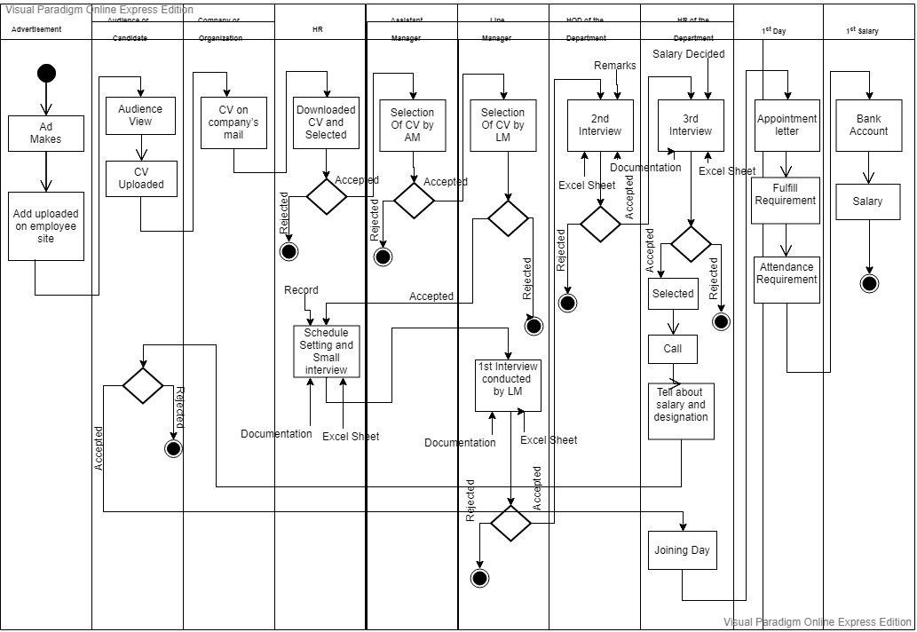

1.1: The figure below show the swim lane workflow of the system.

**BUSINESS DOCUMENT WORKFLOW:**

In business document work flow the company saves all the details of the employees in the excel sheet. They save the details of the new recruits in the excel sheet. At the time of interview they save the details and remarks manually by entering it into the excel sheet and. Similarly they save the details of any thing manually and then convert it in to an Excel sheet.

**CONTEXT DIAGRAM:**

Context diagram is a diagram in which we simply attached all the work flow to the system. There every work is attached to the system. Each arrow that points inwards arrow show the use cases of the given system.

1.2: The figure below show the context diagram of the system.

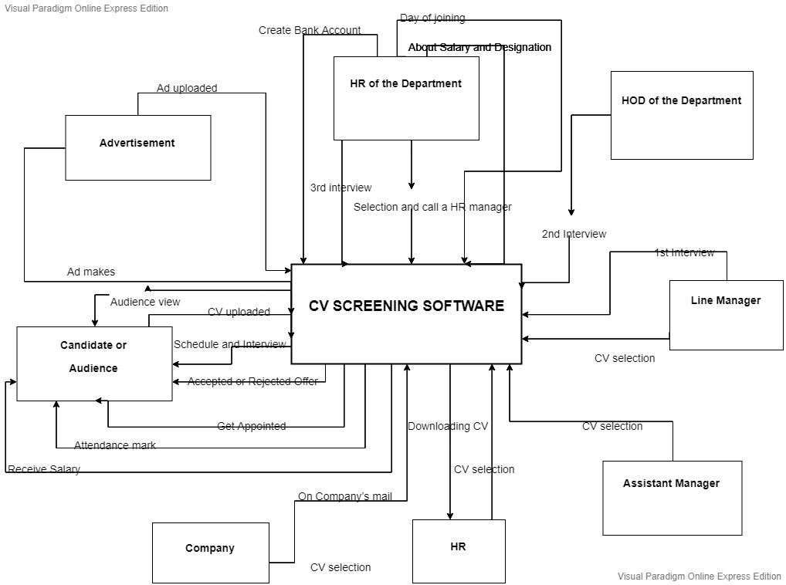

**OBJECT DIAGRAM:**

In object diagram we describe all the use cases with their attributes, methods, relationship with each other .For every use case we have some transactions that is there is an actor, line item, transaction, other Associates for every use case. In our case we have an use case advertisement making which is done by the employee which is our actor and they need to login in order to update, add, insert, delete details of the employees which is other associates

1.3: The figure below show the object diagram of the system.

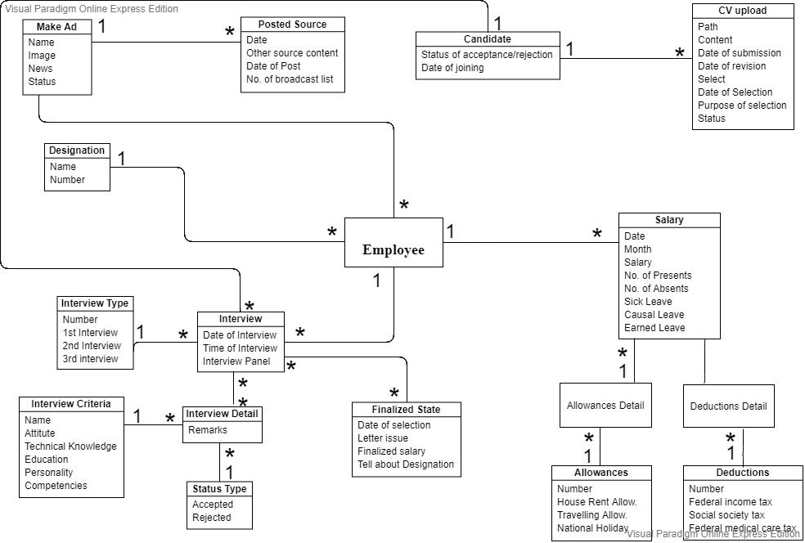

**ACTOR USE CASE DIAGRAM:**

In actor use case diagram there is an individual actors for every use case. There are some actors which do some work. Firstly we have an actor or employee which make the advertisement and uploaded on the employee site, second we have an actor which is candidate which upload CV on the employee site. Then we have an HR which downloads all the CV one by one and select the CV according to the requirements. After selection of CVs she call the candidate and take the small interview and sets the first interview details. Then first interview is conducted by a line manager then the second interview is conducted by the HOD of the department then the last or the final interview is conducted by the HR of the department. If the remarks of the candidate is good and its overall attitude is acceptable then he/she call for the job. If he/she accepted the job then HR tell about the salary, designation and the joining date. On the day of joining he/she gets the appointment letter and HR create bank account for the candidate for his/her monthly salary. Mark their attendance according to their status and deposited salary to his/her account.

1.4: The figure below show the actor use case diagram of the system.

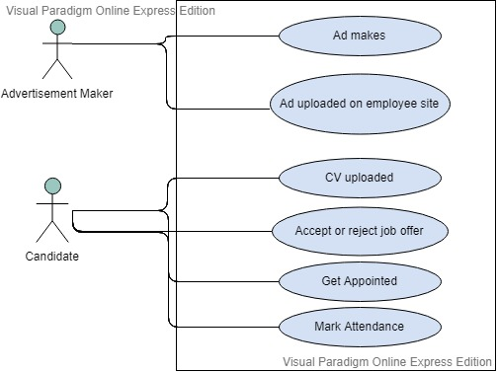

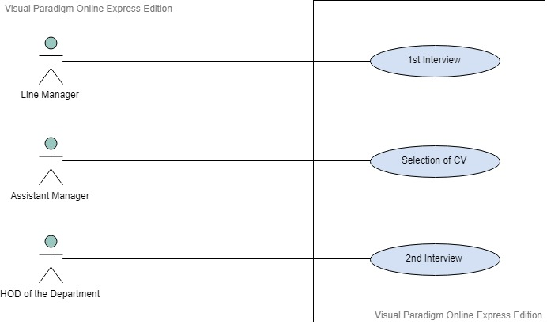

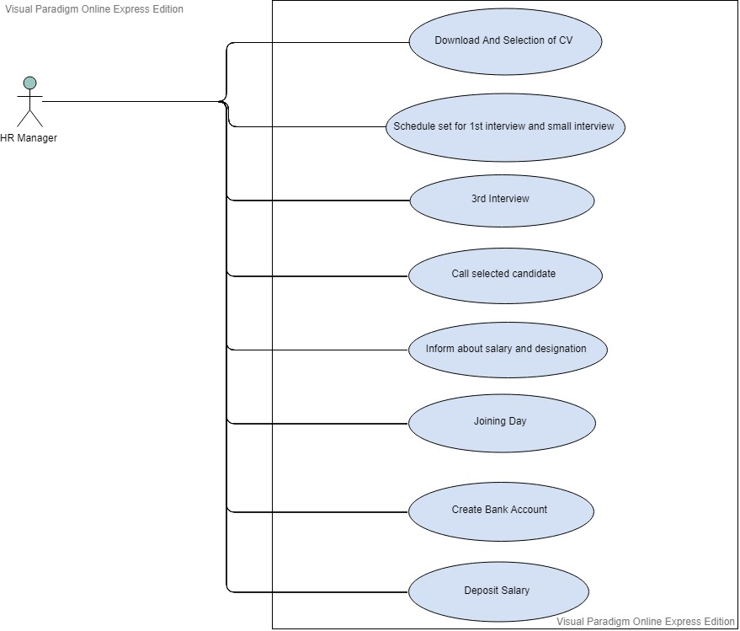

**USE CASE NARRATION:**

1.5: The figure below show the actor use case narriation of the system.

**CV SCREENING SYSTEM**

**Author (s): _______________ Date: _17-05-19_**

**Version: __1.00_________**

|  |  |  |  |
| --- | --- | --- | --- |
| **USE CASE NAME:** | CV Uploaded | | **USE CASE TYPE** |
| **USE CASE ID:** | Cv-u123 | | Business Requirements: **🞏** |
| **PRIORITY:** | High | | System Analysis: 🞏 |
| **SOURCE:** | Candidate | | System Design: **🗹** |
| **PRIMARY BUSINESS ACTOR** | Candidate | | |
| **PRIMARY SYSTEM ACTOR** | HR | | |
| **OTHER PARTICIPATING ACTORS:** | * RECENT EMPLOYER * X-CANDIDATE | | |
| **OTHER INTERESTED STAKEHOLDERS:** | * HR | | |
| **DESCRIPTION:** | In this use case the candidate uploaded cv on company’s mail for the job. | | |
| **PRE-CONDITION:** | The candidate must see the advertisement. | | |
| **TRIGGER:** | The candidate uploaded her/him cv. | | |
| **TYPICAL COURSE** | Actor Action | System Response | |
| **OF EVENTS:** | **Step 1**: Candidate seen the advertisement | **Step 3**:downloaded cv by the HR. | |
|  | **Step 2**: Candidate uploaded cv on company’s mail. |  | |
| **ALTERNATE COURSES:** | **Alt-step 1**: when CV uploaded by the candidate 🡪 we tell them the  Subject of mail should be your position which you have been applied for but we have to Check and download it in separately. | | |
| **CONCLUSION:** | This use case conclude when the candidate uploads a cv. | | |
| **POST-CONDITION:** | The candidate are not eligible. | | |
| **BUSINESS RULES** | * Follow the format. | | |
| **IMPLEMENTATION CONTRAINTS AND SPECIFICATIONS** | * The person uploaded CV according to the given format, subject should be his/her positon and department which he is applied for. | | |
| **ASSUMPTIONS:** | * Pre-condition: the candidate must see advertisement. * Post-condition: The candidate may be applied for given position or not. | | |
| **OPEN ISSUES:** | If he does not use field name in the CV properly there will be problem like it will not scan or recognize his CV properly. | | |

**CV SCREENING SYSTEM**

**Author (s): _______________ Date: _17-05-19_**

**Version: __1.00_________**

|  |  |  |  |
| --- | --- | --- | --- |
| **USE CASE NAME:** | Downloading | | **USE CASE TYPE** |
| **USE CASE ID:** | Dsc-345 | | Business Requirements: **🞏** |
| **PRIORITY:** | High | | System Analysis: 🞏 |
| **SOURCE:** | Company mail | | System Design: **🗹** |
| **PRIMARY BUSINESS ACTOR** | HR | | |
| **PRIMARY SYSTEM ACTOR** | HR | | |
| **OTHER PARTICIPATING ACTORS:** | * Line manager * Assistant manger | | |
| **OTHER INTERESTED STAKEHOLDERS:** | * HR | | |
| **DESCRIPTION:** | In this use case the HR downloads the cv from company’s mail and select appropriate CVs in the minimum time. | | |
| **PRE-CONDITION:** | CV must be downloaded | | |
|  | Then the HR select the CVs. | | |
| **TYPICAL COURSE** | Actor Action | System Response | |
| **OF EVENTS:** | **Step 1**: HR click on the downloading button. | **Step 2**: Download in the folder. | |
|  | **Step 3**: HR open all the CVs one by one | **Step 4**: HR select the appropriate CVs. | |
| **ALTERNATE COURSES:** | **Alt-step 2:** when we download it; it should by default save automatically in different folders according to their department they applied for. | | |
|  | **Alt-step 4:** she has to select CV’s manually thus work has to be done by software like searching some keywords. Like experience, qualification etc. When she search eligible candidates CV’s. she has to search keywords but there is a lot synonyms words so we give options like experience, qualification ,certification so the software search it out and find relatable CV’s. | | |
| **CONCLUSION:** | This use case concludes that HR downloads CVs and select CVs of the eligible candidates. | | |
| **POST-CONDITION:** | The CV may be selected or not | | |
| **BUSINESS RULES** | * CV should be selected by HR and Line manager and CV downloaded by HR, CV can only be seen by the HR and line manager. * HOD of the department which he is applied for only see CV during interview. | | |
| **IMPLEMENTATION CONTRAINTS AND SPECIFICATIONS** | * Using interface and hierarchies a CV automatically download in a specific folder like if its subject belong to finance department it should download in finance folder. | | |
| **ASSUMPTIONS:** | * CV may be selected or not | | |
| **OPEN ISSUES:** | May be you are eligible but due to not properly following the fields there is a possibility that your CV can be rejected. | | |

**CV SCREENING SYSTEM**

**Author (s): _______________ Date: _17-05-19_**

**Version: __1.00_________**

|  |  |  |  |
| --- | --- | --- | --- |
| **USE CASE NAME:** | Interview | | **USE CASE TYPE** |
| **USE CASE ID:** | Icv-678 | | Business Requirements: **🞏** |
| **PRIORITY:** | High | | System Analysis: 🞏 |
| **SOURCE:** | Candidate | | System Design: **🗹** |
| **PRIMARY BUSINESS ACTOR** | HR | | |
| **PRIMARY SYSTEM ACTOR** | HR | | |
| **OTHER PARTICIPATING ACTORS:** | * Line manager * HOD of the department * HR of the department | | |
| **OTHER INTERESTED STAKEHOLDERS:** | * HR | | |
| **DESCRIPTION:** | In this use case the first interview is conducted by line manager, second interview is conducted by the HOD of the department and finally the last or the third interview is conducted by the HR of the department. | | |
| **PRE-CONDITION:** | Must clear/pass all the interviews. | | |
| **TRIGGER:** | It is eligible for job. | | |
| **TYPICAL COURSE** | Actor Action | System Response | |
| **OF EVENTS:** | **Step 1**: first interview which is conducted by line manager. | **Step 2**: Remarks are recorded on excel sheet, fields like experience, attitude, technical knowledge, education, personality, competencies, decision making. | |
|  | **Step 3**: Second interview which is conducted by HOD of the department. | **Step 4**: Remarks are recorded on excel sheet, fields like experience, attitude, technical knowledge, education, personality, competencies, decision making. | |
|  | **Step 5:** Third interview which is conducted by the HR of the department. | **Step 6:** Remarks are recorded on excel sheet, fields like experience, attitude, technical knowledge, education, personality, competencies, decision making. | |
| **ALTERNATE COURSES:** | No alternative way. | | |
| **CONCLUSION:** | In this use case we conclude that the candidate must passed all interviews to get the job. | | |
| **POST-CONDITION:** | Accepted or rejected job. | | |
| **BUSINESS RULES** | * CV with cover letter an all documents should be with you when you came for --interview each time. | | |
| **IMPLEMENTATION CONTRAINTS AND SPECIFICATIONS** | * _____________________________ | | |
| **ASSUMPTIONS:** | * Accepted or rejected job. | | |
| **OPEN ISSUES:** | May be she/he forget cover letter or CV or other necessary documents, because of this may be there is a possibility that interview will not be conducted. | | |

**CV SCREENING SYSTEM**

**Author (s): _______________ Date: _17-05-19_**

**Version: __1.00_________**

|  |  |  |  |
| --- | --- | --- | --- |
| **USE CASE NAME:** | Attendance mark | | **USE CASE TYPE** |
| **USE CASE ID:** | Amcv-897 | | Business Requirements: **🞏** |
| **PRIORITY:** | High | | System Analysis: 🞏 |
| **SOURCE:** | Candidate | | System Design: **🗹** |
| **PRIMARY BUSINESS ACTORR** | HR | | |
| **PRIMARY SYSTEM ACTOR** | HR | | |
| **OTHER PARTICIPATING ACTORS:** | * Employees of company * HOD’s * Managers * Staff | | |
| **OTHER INTERESTED STAKEHOLDERS:** | * HR | | |
| **DESCRIPTION:** | In this use case the HR records the attendance. | | |
| **PRE-CONDITION:** | Attendance mark | | |
| **TRIGGER:** | Attendance mark by candidate if machine not work properly he will contact to HR. | | |
| **TYPICAL COURSE** | Actor Action | System Response | |
| **OF EVENTS:** | **Step 1**: the candidate marks his /her attendance manually. | **___** | |
| **ALTERNATE COURSES:** | **Alt-step 1:** This work should be done by software for keeping records or a personal information or other information like if he/she is on leave but he has now at that position that he has no extra days for leave (the amount will be deduct from his salary) even in convince (deduct money from salary) or car from company. | | |
| **CONCLUSION:** | In this use case we conclude that the attendance of the candidate should be marked. | | |
| **POST-CONDITION:** | Attendance can be marked or not. | | |
| **BUSINESS RULES** | * _______________ | | |
| **IMPLEMENTATION CONTRAINTS AND SPECIFICATIONS** | * By taking thumb impression we will ma the attendance by date & time. | | |
| **ASSUMPTIONS:** | * Attendance can be marked or not. | | |
| **OPEN ISSUES:** | May the thumb impression is not working properly.  May the person forget to make the attendance. | | |

**CV SCREENING SYSTEM**

**Author (s): _______________ Date: _17-05-19_**

**Version: __1.00_________**

|  |  |  |  |
| --- | --- | --- | --- |
| **USE CASE NAME:** | Selection of CVs | | **USE CASE TYPE** |
| **USE CASE ID:** | Soc-897 | | Business Requirements: **🞏** |
| **PRIORITY:** | High | | System Analysis: 🞏 |
| **SOURCE:** | Download folder | | System Design: **🗹** |
| **PRIMARY BUSINESS ACTORR** | HR | | |
| **PRIMARY SYSTEM ACTOR** | HR | | |
| **OTHER PARTICIPATING ACTORS:** |  | | |
| **OTHER INTERESTED STAKEHOLDERS:** | * HR & Line manager | | |
| **DESCRIPTION:** | In this use case the HR search CV manually in minimum given time then more selection done by line manager among them. | | |
| **PRE-CONDITION:** | Attendance mark | | |
| **TRIGGER:** | Attendance mark by candidate if machine not work properly he will contact to HR. | | |
| **TYPICAL COURSE** | Actor Action | System Response | |
| **OF EVENTS:** | **Step 1**: HR open all the CVs one by one | **Step 2:** HR select the appropriate CVs | |
|  | **Step 3**: HR select CVs. | **Step 4**: HR select CVs on the basis of experience, qualification, technical knowledge and hard and soft skills. | |
|  | **Step 5**: More selection done by assistant manager. | **Step 6**: Select appropriate CVs. Assistant manager select CVs on the basis of experience, qualification, technical knowledge and hard and soft skills. | |
|  | **Step 7**: The line manager select the best CVs again among the selected CVs given by HR. | **Step 8**: Select appropriate CVs. Line manager select CVs on the basis of experience, qualification, technical knowledge and hard and soft skills. | |
| **ALTERNATE COURSES:** | **Alt-step 9:** She has to select CVs manually thus work has to done by software like searching some keywords. Like experience, qualification etc. When she search eligible candidates CVs. She has to search keywords but there is a lot of synonyms words so we give options like experience, qualification, certifications so the software search it out and find relatable CVs. | | |
| **CONCLUSION:** | So the line manager and the assistant manager decides which candidate is eligible. | | |
| **POST-CONDITION:** | The CV may be selected. | | |
| **BUSINESS RULES** | * CV should be selected by HR and Line manager and CV downloaded by HR, CV can only be seen by the HR and line manager. * HOD of the department which he is applied for only see CV during interview. | | |
| **IMPLEMENTATION CONTRAINTS AND SPECIFICATIONS** | * ______________________________ | | |
| **ASSUMPTIONS:** | * CV may be selected or not. | | |
| **OPEN ISSUES:** | May be you are eligible but due to not properly following the fields your CV can be rejected. | | |

**CLASS DIAGRAM:**

1.6: The figure below show the class diagram of the system.

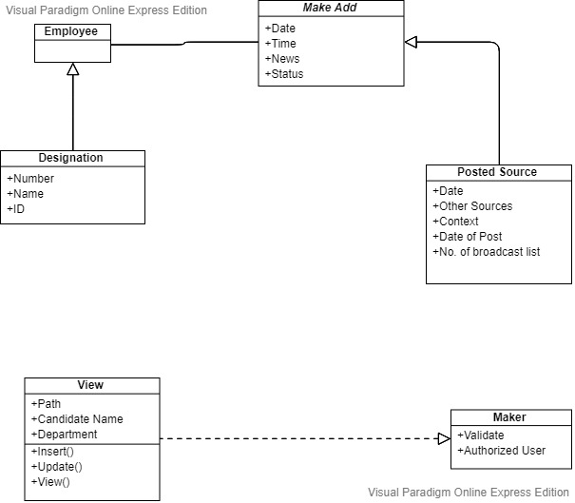

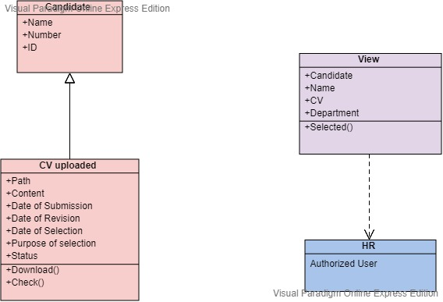

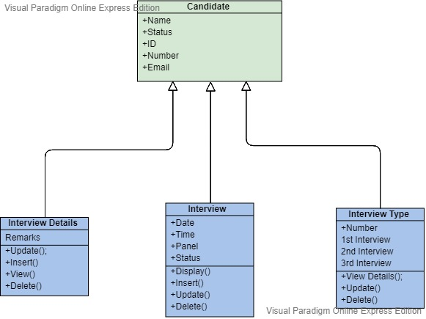

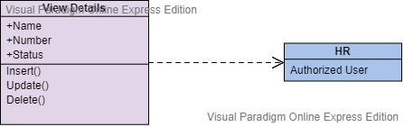

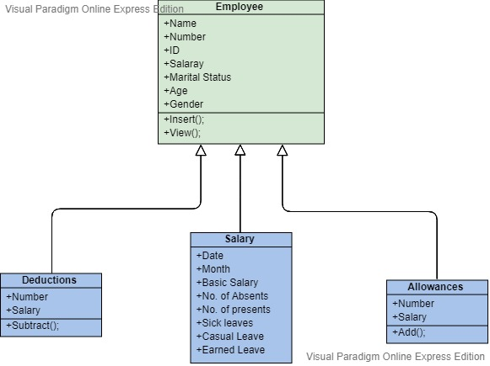

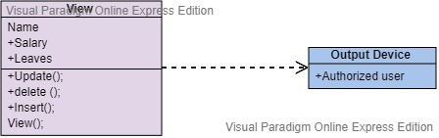

**SEQUENCE DIAGRAM:**

In sequence diagram we show the action of the user (HR). When the HR successfully login then he/she can able to manage employee details. And also manage CVs, interview details, interview remarks and salary for the candidate.

1.7: The figure below show the actor use case diagram of the system.

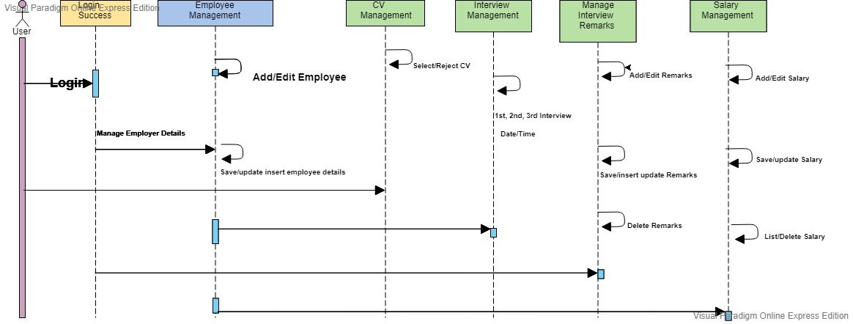

HR

**INPUT DESIGN PROTOTYPE:**

1.8: The figure below show the input design prototype of the system.

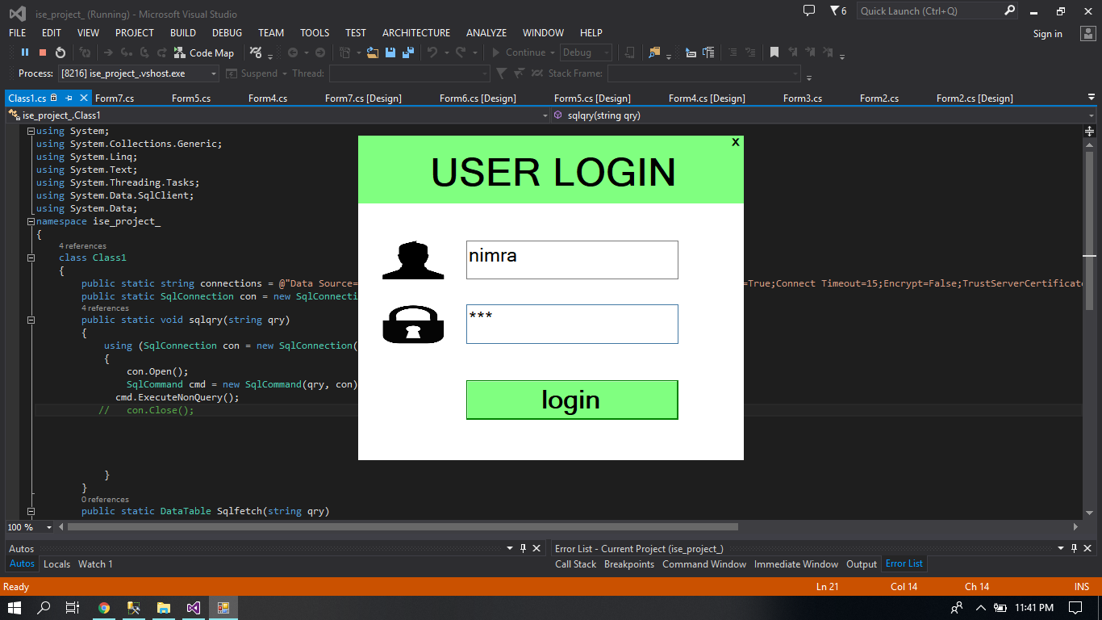

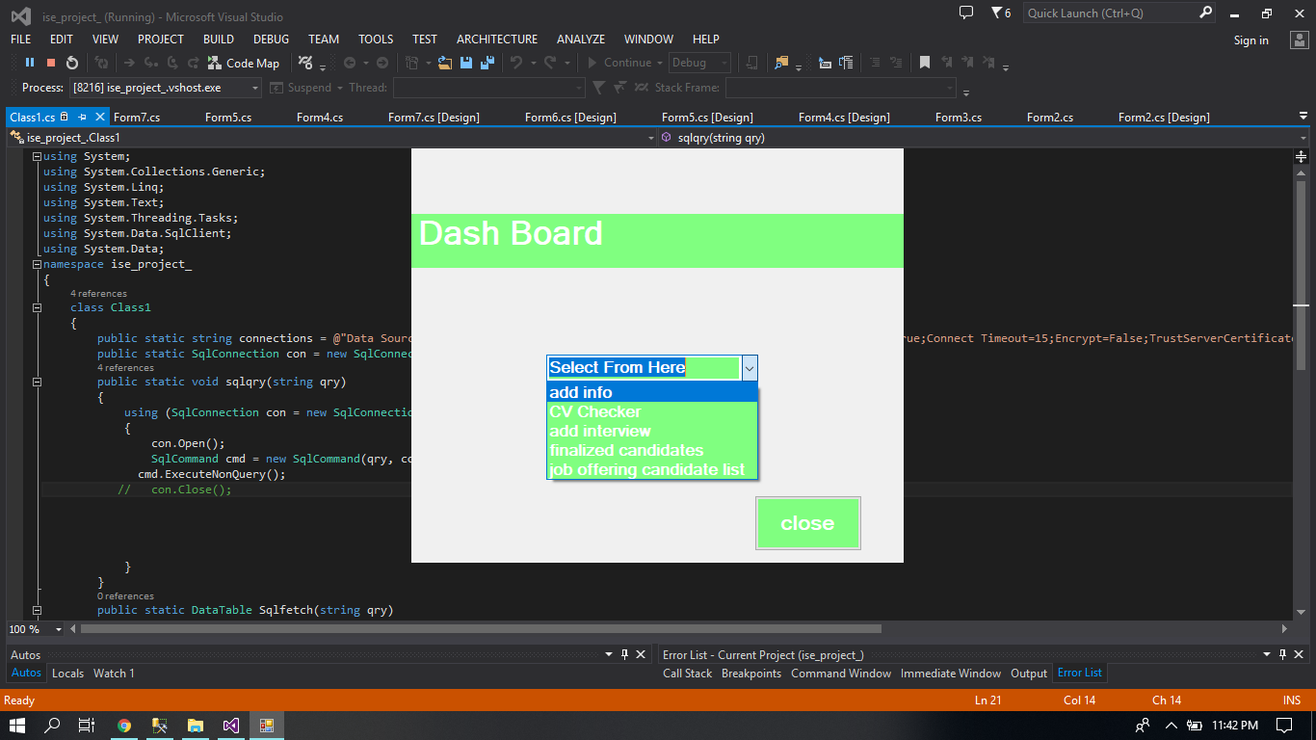

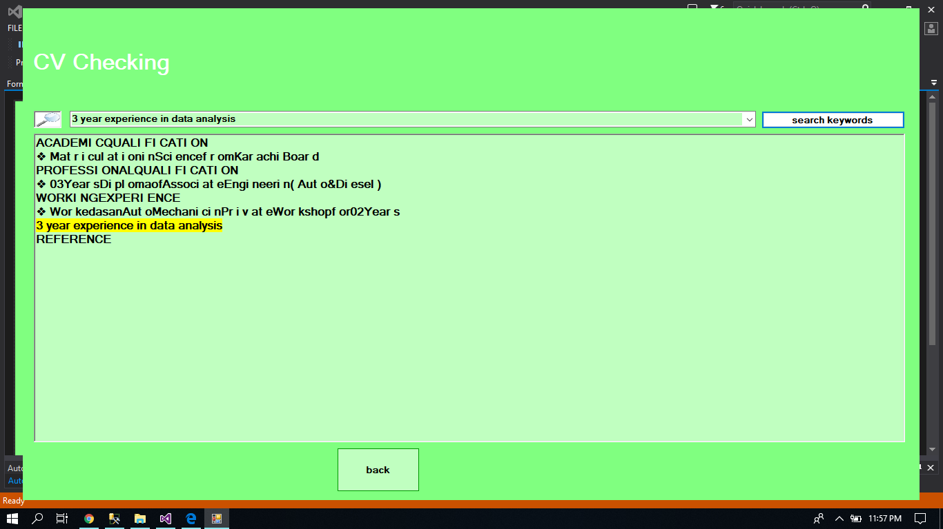

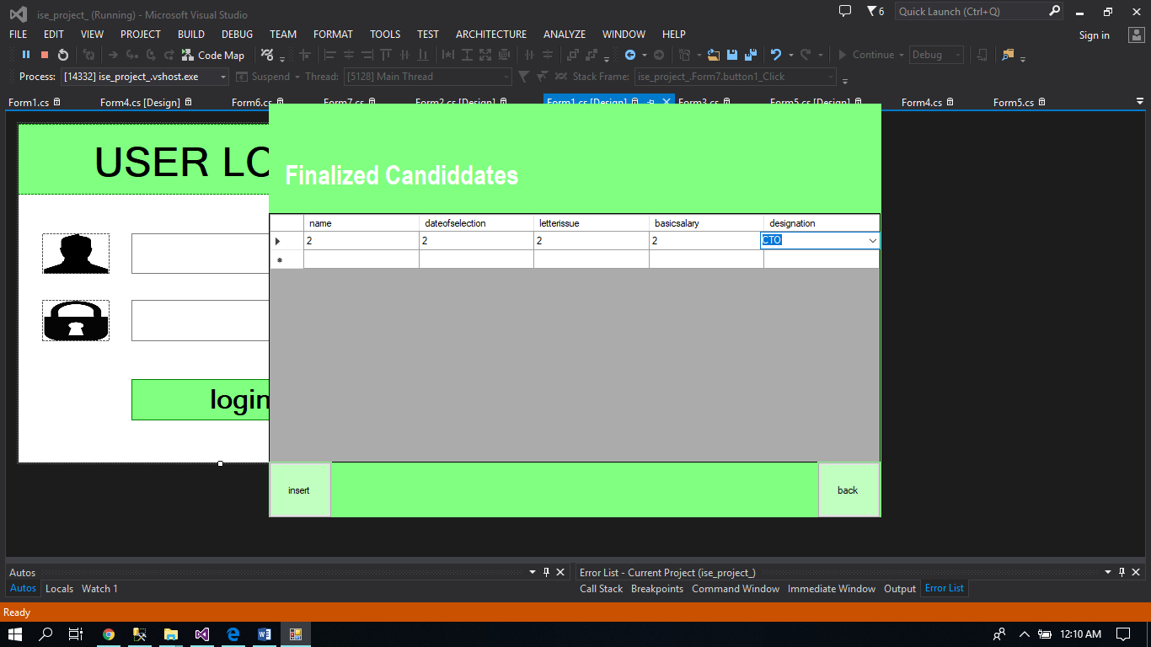

**OUTPUT DESIGN PROTOTYPE:**

1.9: The figure below show the output design prototype of the system.

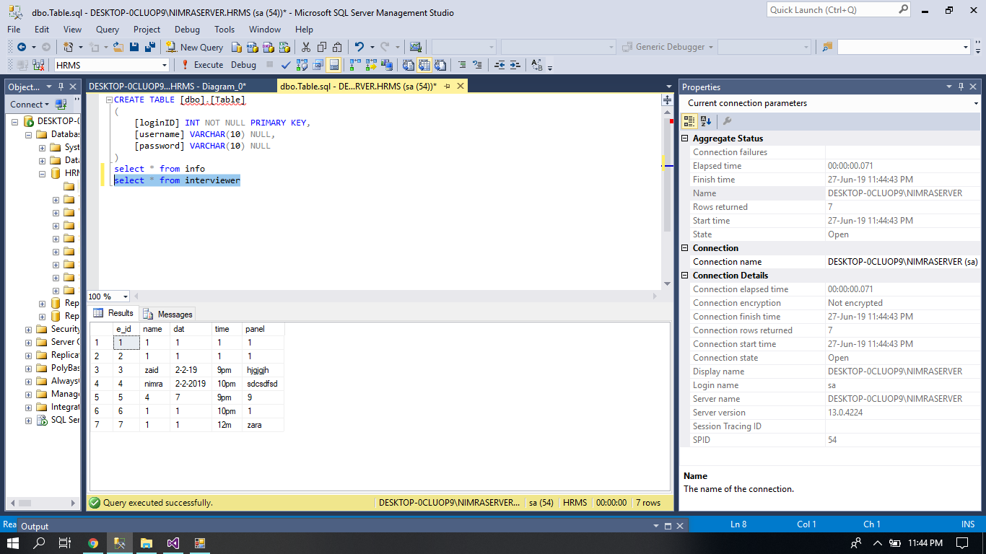

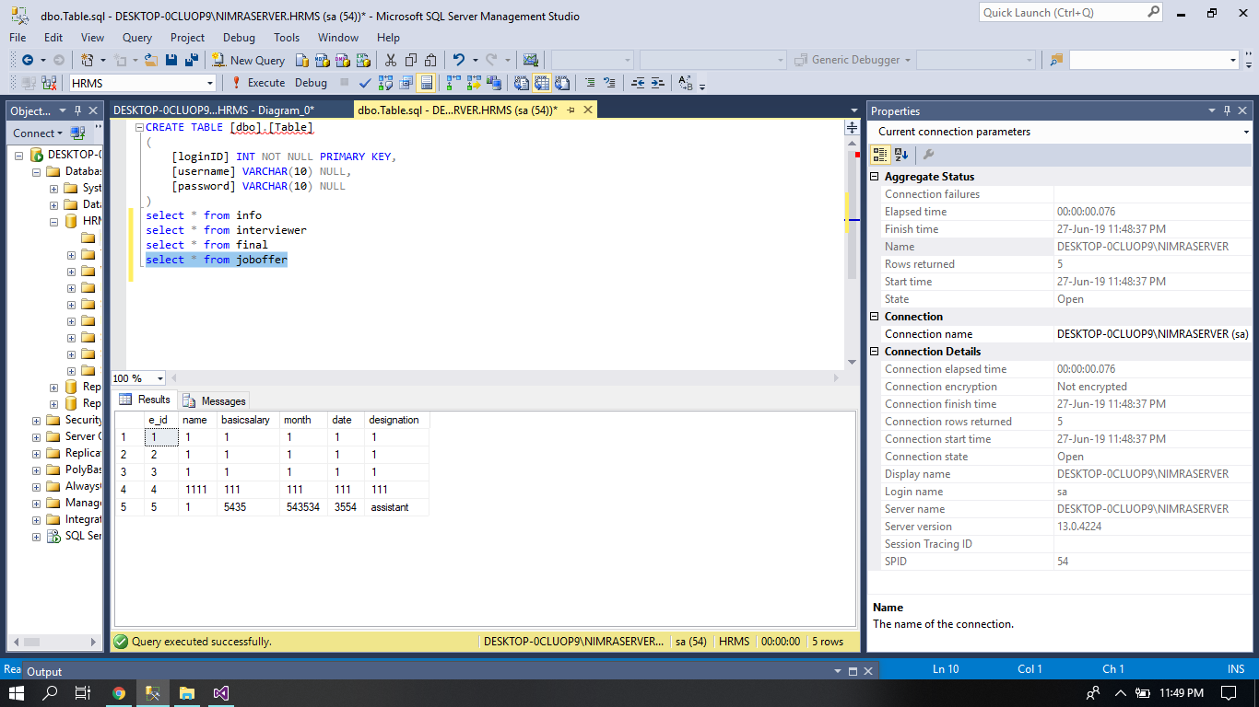

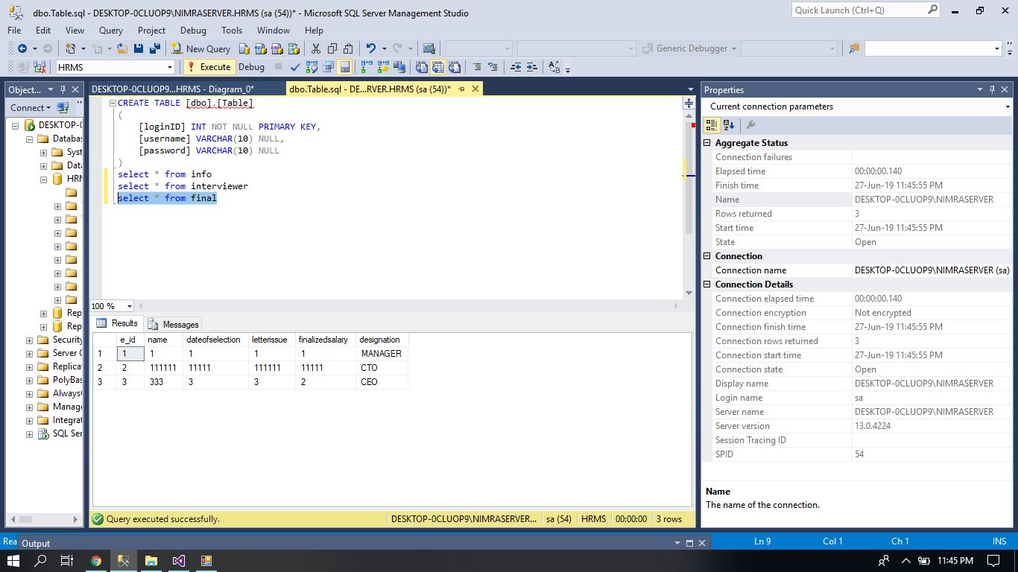

**DATABASE DIAGRAM:**

1.10: The figure below show database diagram of the system.

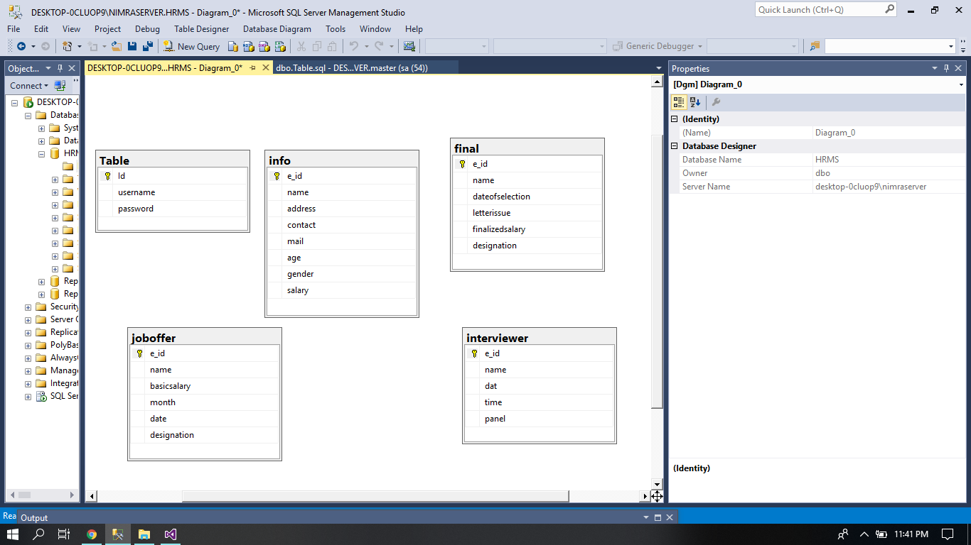

2.1: The table below show the actor use case table of the system.

**ACTOR USE CASE TABLE:**

Actor use case table is also called use case narration.

In this diagram we describe the steps of each use case .in this diagram we discuss the flow of the work according to their specification

|  |  |  |  |  |
| --- | --- | --- | --- | --- |
| Usecase | Primary actor | system actor | other participating actor | other interested stakeholder |
| CV uploaded | candidate | HR | Recent employer  Ex-candidate | HR |
| Downloading | HR | HR | HR | HR |
| Interview | candidate | HR | Line Manager  HOD of department  HR of Department | HR |
| Attendance Mark | HR | HR | Employee of company  HOD’s  Managers  Staff | HR |

2.2: The table below show the actor use case report of the system.

|  |  |
| --- | --- |
| Usecase | Reports |
| CV uploaded | **Detailed**  List of candidates  List of broadcast  **Summary**  Candidate upload CV on company’s mail  **Exception**  No CV uploaded, incorrect format  Invalid input exception |
| Downloading | **Detailed**  List of candidates  List of broadcasts  **Summary**  The HR manager downloads CV from company’s mail. |
| Interview | **Detailed**  List of candidates  List of broadcast  **Summary**  The first interview is conducted by line manager, 2nd by HOD and 3rd by HR manager of department |
| Attendance Mark | **Detailed**  List of candidates  List of broadcast  **Summary**  HR records attendance. |

Implementation

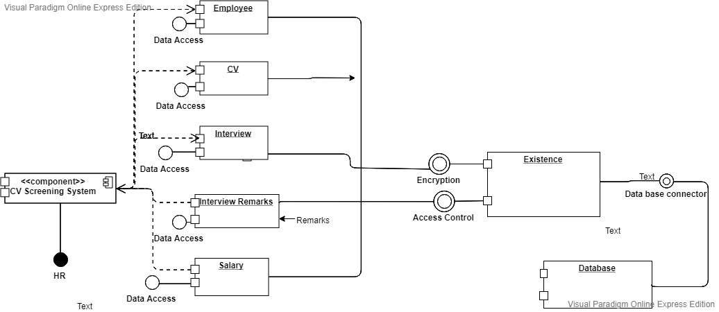

1.11: The following figure above is the component diagram

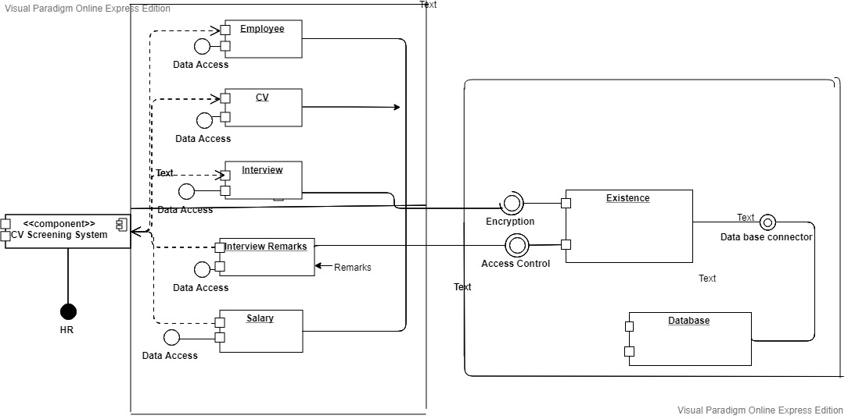

1.12: The following figure above is the deployment diagram

Support

We are providing a healthy and supportive environment for our customers and are giving away a 6 month warranty for our program that if any error occurs within duration in the software then we will be gladly help our valuable customers in fixing the problem free of cost.

We also believe in taking feedback from our valuable customers to improve our products quality.

AIMAN ALI

(17B-004-SE)

AREEBA KALEEM

(17B-015-SE)

NIMRA MEHBOOB

(17B-045-SE)

Conclusions and Suggestions for Future Work

The work accomplished in the project is to successfully edit delete and save the remarks of the interviewed employee on the spot instead of loading the work and saving them in excel sheets which is a lot of tiring work. Furthermore to also enabling CV searching in the our product providing the opportunity to go through the CV in a fast pace. For future our goal is to automatically download and save the CVs at the certain folder. Furthermore many developments can be made i.e. the software would read without a certain format and many various contribution can be made towards the ease of the employees while hiring a new recruit.

References

### Book example:

1. [Rog82] Pressman, Roger S. *Software Engineering: A Practitioner's Approach*. New York: McGraw-Hill, 1987. Print.

### Website Reference:

1. <https://www.youtube.com/watch?v=Z_hEj2U_5tI>
2. <https://www.youtube.com/watch?v=QmT1oec1YBc>
3. <https://www.youtube.com/watch?v=_4Dpp_b6tKU>
4. <https://www.youtube.com/watch?v=649nnBcqaJw&feature=share>
5. <https://www.youtube.com/watch?v=NX8-LhgFnUU&feature=share>
6. <https://www.youtube.com/watch?v=HhkHvEE-5W0&feature=share>**APPENDICES**

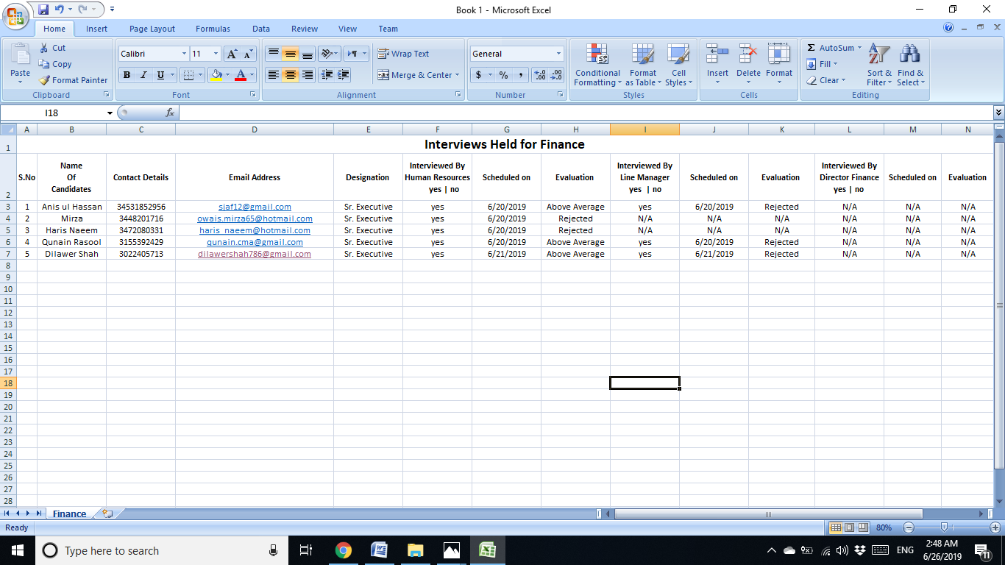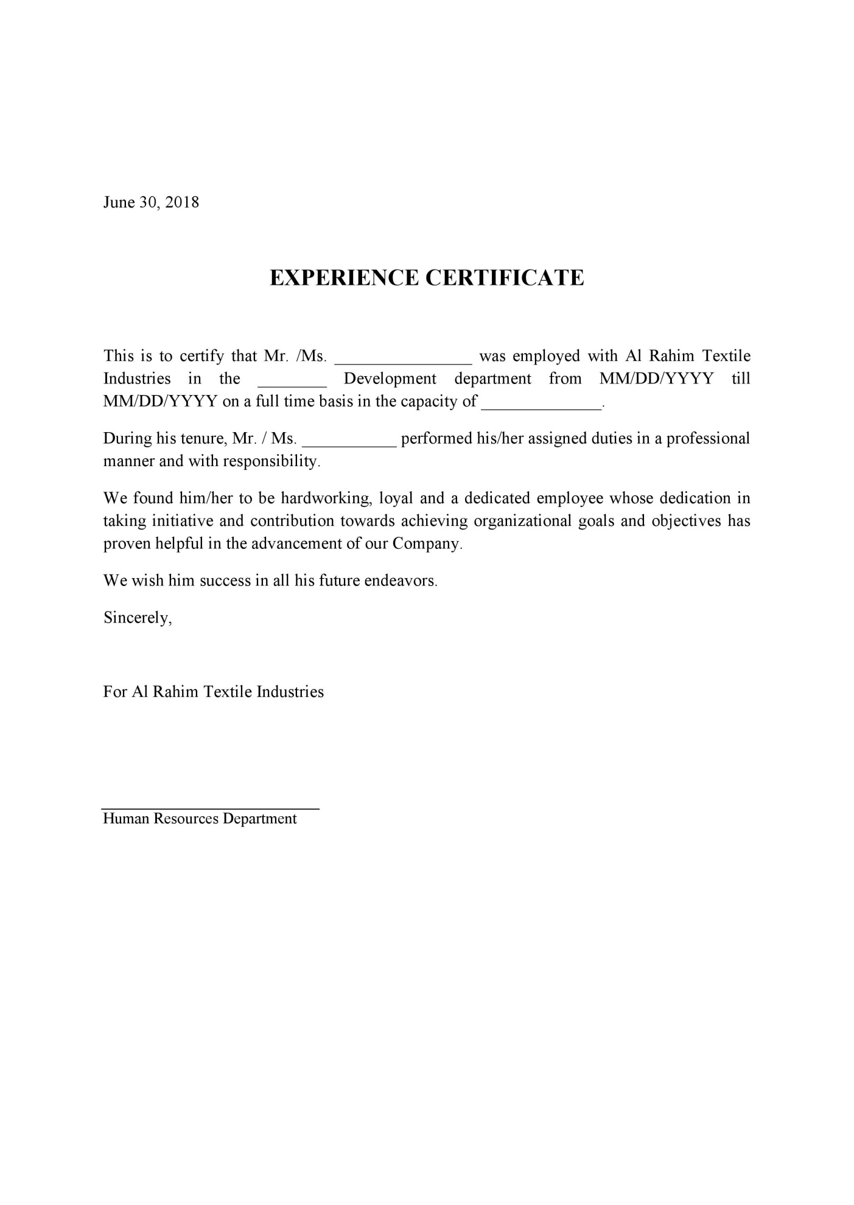

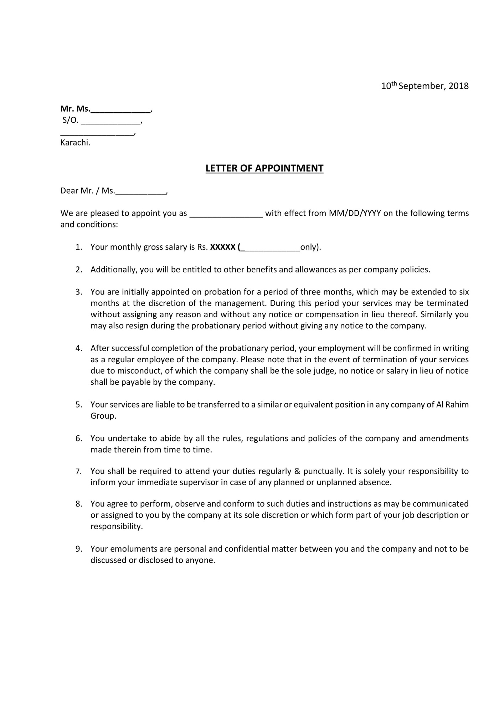

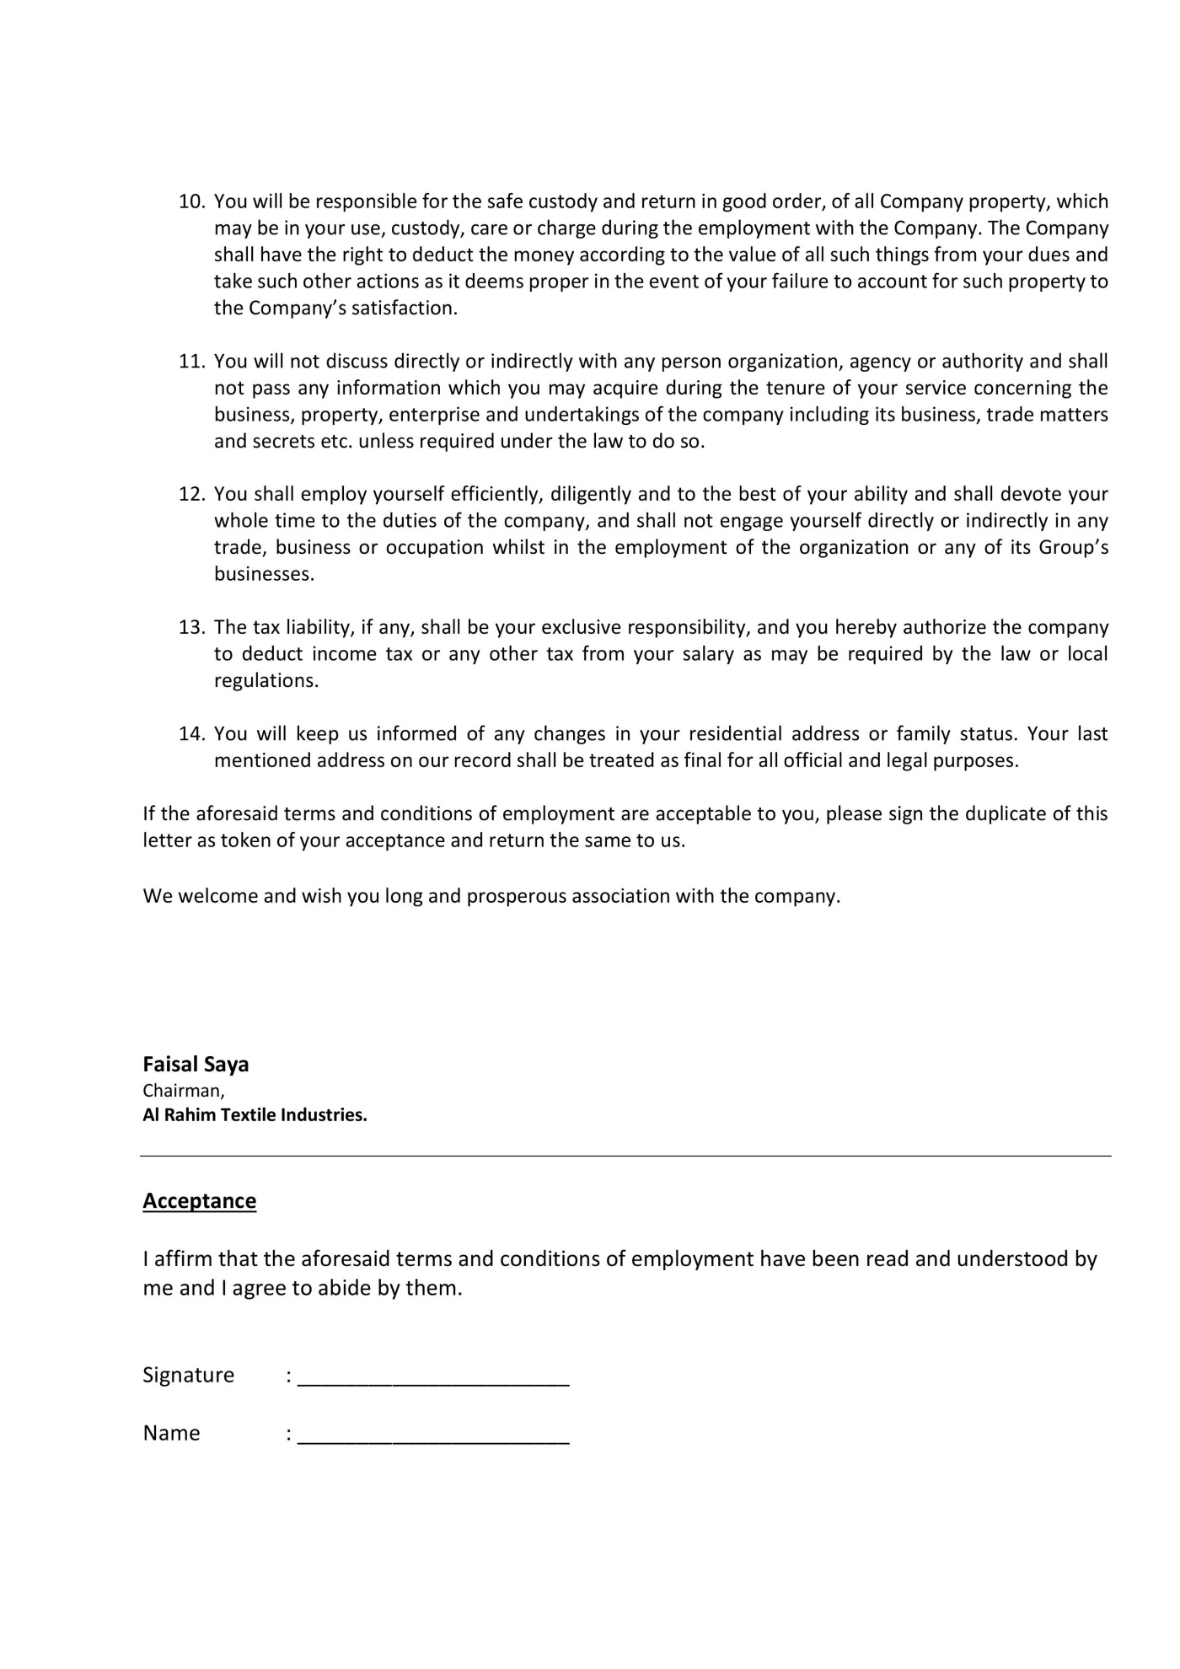

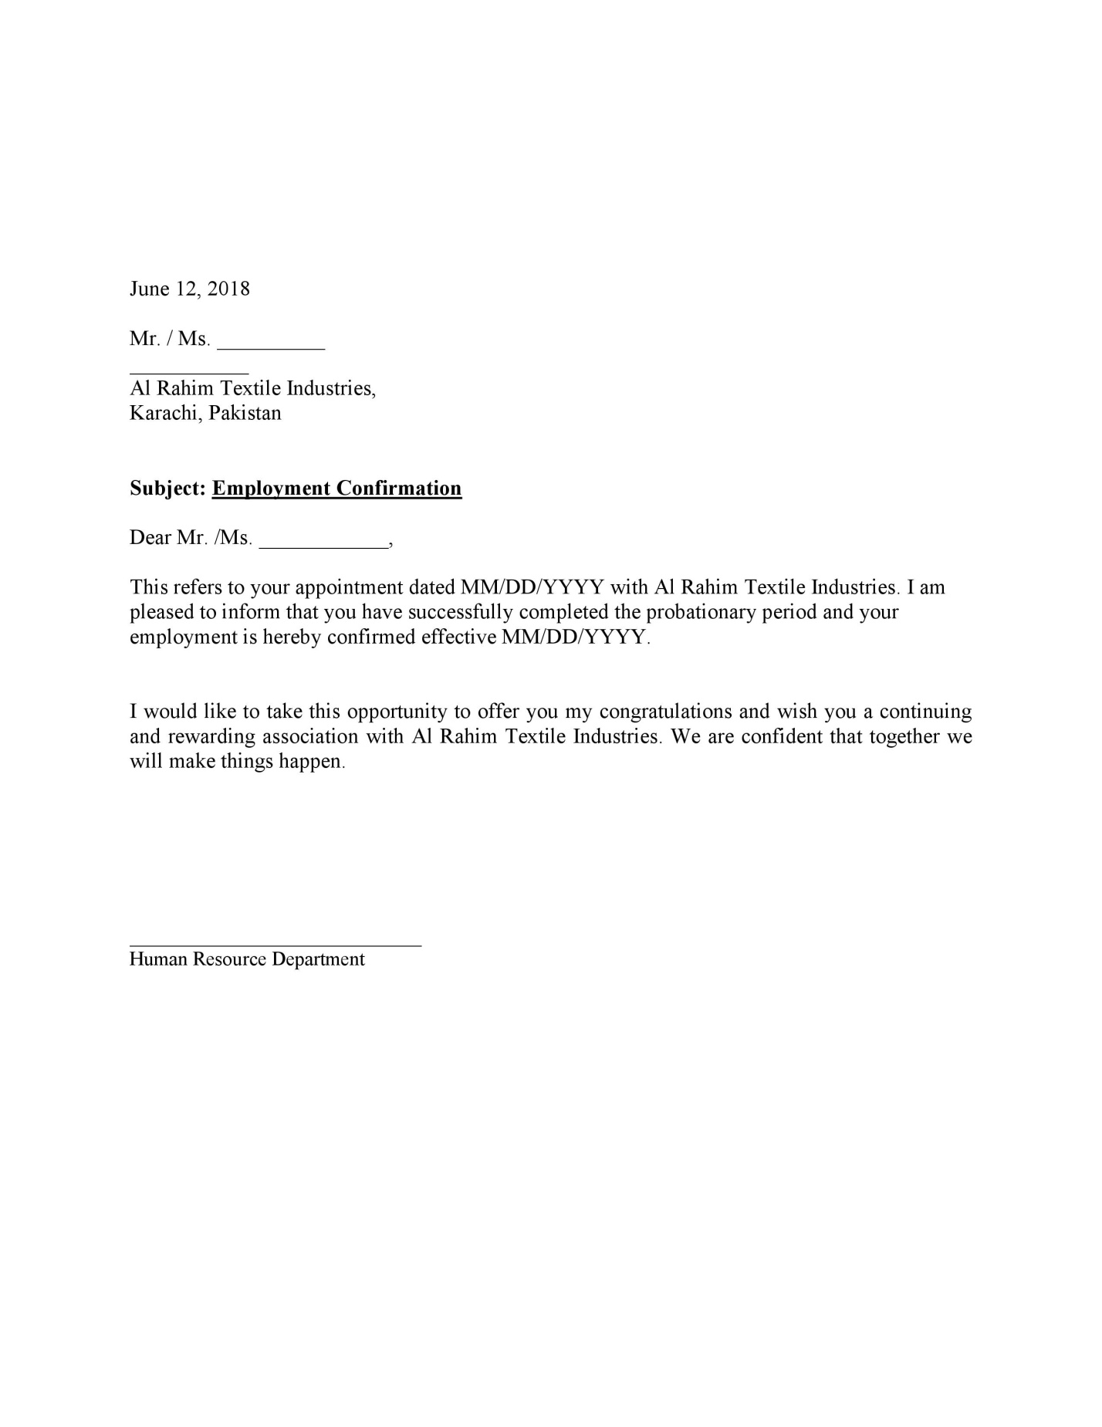

Questionnaire:

1. What type of work is being performed in your organization and how does it work?
2. Which software does the company use?
3. Is there software efficient enough to handle incoming data?

LIST OF SYMBOLS

The following UML notations are used in object oriented analysis and design:

1. + Name
2. + Salary
3. + designation
4. - employee id
5. + date
6. + time
7. + age
8. + gender
9. + marital status
10. + #of absents
11. - #of leaves
12. + # of presents
13. - Gridview_leave();
14. Insert ();
15. Delete();
16. Update();

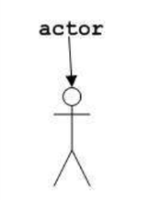

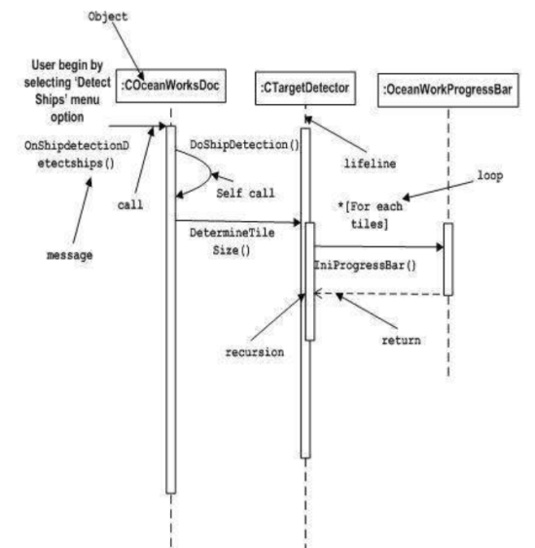 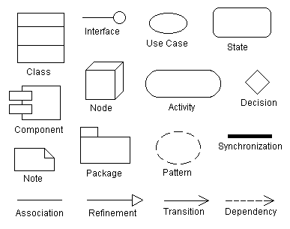

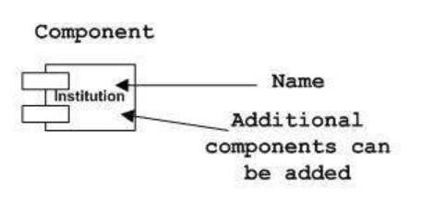 GLOSSARY

UML: Unified Model Language

OOP: Object Oriented Programming

INDEX

Title page, 1

Abstract / Executive Summary, 2

Table of Contents, 3

List of Figures, 4

List of Tables, 5

Acknowledgments, 6

Introduction and Overview, 7

Background, 8

Aim and Statement of Problem, 9

Methods, Assumptions, and Procedures, 10

Available Relevant Slutions and Evaluation, 11

Analysis and Design, 12

Implementation, 40

Support, 42

Conclusions and Suggestions for Future Work, 43

References, 44

Appendices, 45

List of symbols, 49

Glossary, 50